In the Mainstream of XX Century – A Living History
Béla Török
EXTRACT -CARDINAL MINDSZENTY

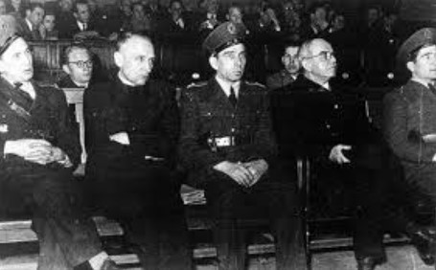
Cardinal Mindszenty’s case shocked us. I was particularly taken aback when I realized that the Chief Judge was Vilmos (William) Olti (Obetkó) about whom I have already written a few lines. His words, in autumn of 1944, rang in my ears. He said that we could not leave Hungary because we have not done anything actionable and we were young people who needed to stand up for this country's reconstruction. How could William Olti have gone this far that as a good Catholic and member of the University Emericánás Society, he could lecture our spiritual pastor?
Cardinal Mindszenty at his sham trial by the Communist masters
My friend, John Baltay, was concerned that Peter Jankó (the “bloody” judge of the Rajk trials), who became president of NOT, could go the same way. He thought that Jankó’s wife’s origin contributed to his discomfort, but does not explain his change of heart. Peter Jankó finally put an end to his life with his own hands.
The judges also became victims. At this time, I heard that Tamás (Thomas) Simándy, who was a well-known "communist", became a member of the Justice Ministry and one of the Presidents of NOT. He was unable to deliver the death sentences as was prescribed to him. He was challenged for his mild judgments favoring the war criminals. Finally, he gave in his resignation and withdrew. He dreamed of Hungary’s social regeneration, but he could not find a place in this system for the cruel, foreign interests.
We watched the news because our loved ones continued to send the coded message – "We would welcome Béla’ home!" This suggested that if I went home, a prison ordeal was probably waiting for me. Why? I wondered what the crime was. I never denied that I regarded the II World War as the demolition of the Versailles order and I awaited the collaboration with the Germans for the revision of the Trianon borders. I was not involved in politics and as a legal person was not a member of any political party. My Job did not involve me in political issues. It is possible that being the personal secretary István Antal would count against me. However, the fact that I also worked next to Gábor Vladár, the Lakatos government’s minister somehow didn’t count.

In 1985, István (Stephen) Eszterhás’s book The Cardinal and the Guard, a classic psychoanalysis of Joseph Mindszenty’s mental battle, while exiled in the U.S. embassy, was published and I even tried to help Steve in his book dissemination. The local newspaper also praised this work.
But perhaps it would be best if the writer spoke again:
"I met the cardinal at home and from the beginning of his bondage I wrote about it. In his diary, he often praised Sunday. He could now read in the U.S. embassy. When he was finally free, our meeting shocked me.
The book had unusual repercussions. There were people who wanted to stick to their memory of him and rejoiced in the book. But there were people who, while he walked among us fought hard to be near him, but today wondered coldly why this book was necessary?
Even if this book cost me money, I will lovingly pamper it because we Hungarians in literature have always felt a debt to our national greats. In our time, the greatest Hungarian was József Mindszenty and in literature no one had paid him homage. "
The year was1974 – it was a significant year for the emigration because this year we were visited by Archbishop Cardinal József Mindszenty, the spiritual leader and father of the Hungarian emigration. Large masses of Hungarians welcomed the chief priest and there were touching scenes between the leading pastor and the devotees. In fact, this also applied to those outside the church. St. Mary's Cathedral, Sydney, was where the cardinal celebrated Mass and the faithful, with much emotion, filed down the aisle to receive the Lord's body from the high priest's hand.
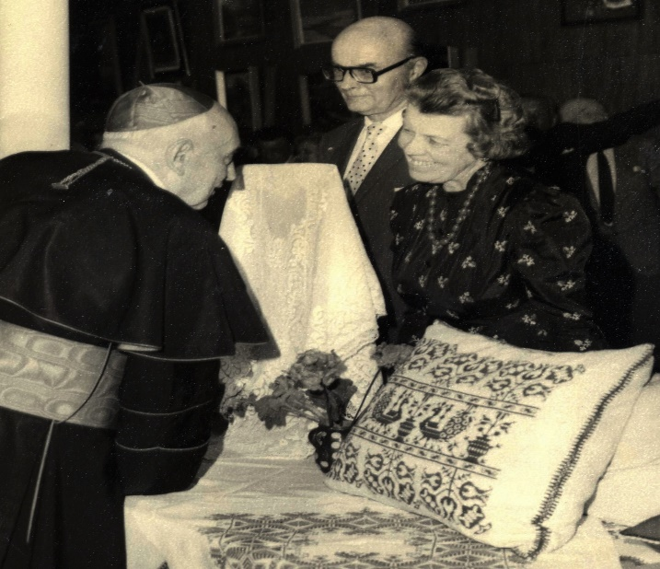
As I proceeded towards the altar, I saw coming towards me my dear friend, Peter Bod who came from a very old Transylvanian family whose ancestors included a famous Calvinist pastor, a prominent figure in Hungarian Protestantism. Peter and his family lived in accordance with the spirit of their ancient traditions. Peter then pulled me aside and whispered: "Béla, I trust I did not commit a great sin that, by being a Protestant, I accepted the wafer from the cardinal's hand?" His words really touched me. His behavior demonstrated the charismatic force which shone from the cardinal.
Cardinal meeting Kalándy family
Many exiled Hungarian Protestant pastors were thinking the same way as my friend Peter. Another good friend of mine Peter Kemény, a Lutheran minister, attended a welcoming reception and concelebrated an ecumenical service with the archbishop.
The Cardinal's visit to Sydney was well organized by the Hungarian colony. Former Gendarmerie (police) were the security guards for the archbishop. My friend István (Stephen) Jani was one of the organizers with his wife, György who was the Cardinal's goddaughter. Pista (Steve) gave the cardinal a copy of my book and who, according to Pista, read it during the many unavoidable waiting times at the many events he attended.
Mariazell Church-tomb of Cardinal Mindszenty
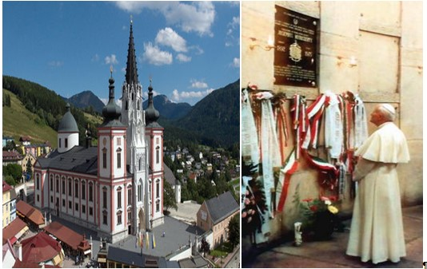
When the archbishop received me in an audience, he discussed parts of my book (Hungary in great detail. It was interesting that the part of the book that he criticized was when I evaluated László Rajk’s behavior. He judged to be too lenient. He pointed out that Rajk was one of those who led the campaign for the annulment of religious schools. The holy prelate did not consider it appropriate that the diaspora visit Hungary as it would be helping the existing regime, which he said was refusing to acknowledge the nations thousand years of history and supported the enemy.
When we said goodbye, he invited me to visit him in Vienna. At this point, we were planning another overseas trip and Vienna was in our program. Unfortunately, I could only pay tribute to him in front of his tomb at the Mariazell church, because by that time he had left us.

