In the Mainstream of XX Century – A Living History
Béla Török
Part 2 -Refugees in Germany and Migrant Life in new Home in distant Australia.

General Mobilizing Order

At this time, a general mobilizing order was proclaimed – “Officers’ marching order" which said that all reserve officers - even if they had been exempted to date – must report at the specified date and place.
On October 6, 1944, on my thirtieth birthday, I had to register at the ‘train barracks’ where the remaining First Reconnaissance Battalion detachment was located.
The Justice Department's policy was that nobody asked for dispensation and so it was natural to have to obey the command. I later learned that this reserve officer recall was one of the steps that were intended for members of the reserve corps to ensure military discipline at the moment of an armistice.
Personally, military service raised mixed feelings in me. Ica and the two little boys had arrived back to our apartment, she was pregnant and the pantry was empty ...at other times I had been happy and eager to serve, but now my heart sank. The impending political truce was displeasing to endure and yet with this reservation I was pleased to don my uniform.
Once again in uniform, I appeared in the Department of Justice as an ensign and I said goodbye to Gábor Vladár...
The sensitive Gábor Vladár obviously felt that my call to arms could result in Russian captivity and stressed that the government was only taking steps that would serve the interests of the nation.
To this I just replied with: "Your Excellency should be assured that the front will fulfill its duty."

Elastic Separation 1944-1945

I embraced Ica, kissed the boys and certainly with a heavy heart caught the tram to Budapest and the Arena Street Train Barracks. The uncertain future, the receding frontline and the confused political situation made this thirtieth birthday very sad.
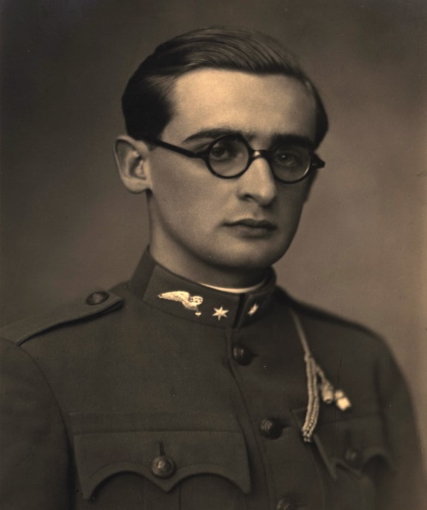
I became a little more cheerful at the barracks, because I met quite a few old comrades and we caught up with each other’s lives since we last met. In a Military sense, there was not much point in our call up. The battalion was fighting at the front and only enough soldiers were needed to allow supplies to be transmitted. There were no armored cars or other heavy weapons in the barracks, since all available equipment had long been directed to the front.
Based on our marching orders, the number of officers reporting was between 16-20yet they could not provide us with jobs. So somehow, we positioned ourselves in the old volunteers’ school dormitories and spent almost all our time idle. Our activity consisted of a few hours in the guard station or in the office next to the actual working officers.
I remember the card parties and listening to a portable radio brought in by one of our friends and tuned to reports from Budapest.
As an Ensign in Army Reserves
Amongst all the news I just remember one. This was the announcement of the fall of Szeged. I know that I was very shocked by this news. I could not imagine that my dear hometown was now under enemy rule...
Once earlier, I could visit home because I got a short-term leave authority. This more recent farewell once again tore the departure wound.
This is how we reached the 15th October. At noon we were just lying on our beds, some of my comrades played cards, but the radio was on.
The radio announcer then said that an important announcement was to be made. We took notice and listened with rapt attention when Miklós Horthy made his fateful announcement. A shocked silence followed the news that ceasefire talks were had with a head of state and an agreement was ready for signing. Our first involuntary thought was the relief that an end to this hopeless fight would ensue. I also thought of home, Ica, children and a glimmer of hope that maybe we can be together again soon...
But then doubts flooded our brains. We had to come face to face with triumphant Bolshevik forces and it was obvious that our Hungary was no longer. Surrender appeared increasingly distasteful.
Many thought of leaving the barracks to avoid having to take part in the humiliating act of surrender.
The political situation was still unknown. Here and there we could hear the noise of weapons and the barrack command banned leave. Then an aircraft roared over our heads and dropped flyers. We read Francis Szálasi’s "armed military command" and it became clear that the Germans would not accept Horthy's plan to exit the war.
With all the uncertainty, I myself was inclined to don civilian clothes and go home, despite the ban on leaving the barracks. I struggled in discussing the situation with one of my comrades who also was an ensign and eventually I could not break my oath and flee the barracks as a deserter. Some of my comrades, however, decided to leave, despite the ban. It was not a problem as the rear area was not patrolled and so it was easy to walk into town.
So I stayed and by the time it got dark we got the news that the German-Hungarian troops occupied the radio station and the chief of General Staff issued orders that the war was not over and that troops needed to comply with the orders issued.
Captain Pataky was commander of the barracks and he told us at an impromptu officers meeting that he would join forces with those who supported the continuation of war. He also informed us that neighboring barracks (mechanized infantry divisions) commander had made a similar decision. He also pointed out that he had phone connection to the Mária Terézia Command headquarters and they too had decided this way.
The phone connection was not without interruptions and the political events were still very confused. Around 10 or 11 PM Captain Pataky decided to send an officer to the Mária Terézia barracks so that he might get a clearer picture of the situation.
Pataky had a sidecar motorcycle courier available and he called me to implement this "discovery" exercise.
Budapest streets were deserted with almost the only traffic being military vehicles. Contours of German Tiger tanks could be seen and we arrived at the Mária Terézia barracks without stops or other unpleasant incidents.
The duty officer's room was filled with staff officers. I reported to the senior officer and conveyed the request of the barracks commander requesting information.
The staff officer explained that the city headquarters was also quite uncertain of the political situation. One thing that was certain - he said - that the general staff headquarters was in favor of the continuation of the war but the political situation was still uncertain. The fact was that Budapest was in the hands of the German-Hungarian forces which were opposed to surrender and the information was that negotiations were taking place with the governor to clarify the situation.
By the next day, things were clearer. The situation seemed to be that the forces rallied around Francis Szálasi, the National Socialist Party and the National League which would form a government and the country would continue to struggle against the Soviet Union.
Order was basically restored in the city and there was hope that the situation had solidified.
I got permission for a leave pass to allow me to confirm that my family had not been harmed. I visited the Ministry of Justice (my place of employment). I noticed a radical change. The atmosphere was still pretty excited, but now the casual conversations even among trusted friends were definitely very cautious. The new Minister of Justice, László Budinszky, was a Budapest lawyer who was a former Nazi party member and representative. He brought a young colleague as his personal secretary. My personal name plate was removed from the ministerial office room entrance. Supposedly on this occasion, it would be moved to my old Draft Department, but it was not in this instance.
We did not know then what had happened to Gábor Vladár, but the new head of the Preparatory Department was Panel Judge Lajos Slezák, who it turned out was secretly a member of the Arrow Cross Party. I met him by chance in the hall and when he saw me - as he was aware that I was an expert in German affairs - declared that he would ask the minister to exclude me from military service. This was natural he said because I was István Antal’s personal secretary and known as one with right wing opinions. I politely took note of his comments, but somehow, I felt that staying a soldier under current circumstances maybe a better solution. László Gál an old family friend and Minister Counsellor thought so too and thought that basically, I have been lucky to be in uniform because this way, I was not exposed to persecution.
Amongst our friends only István Bíbó was removed from service. It was public knowledge, however, that there were many legal draftsmen who did not follow the German line but continued to serve and therefore Bíbó’s arrest was incomprehensible. So, when Lajos Slezák became aware of Pista’s arrest immediately intervened to the Minister and as a result Bíbó was detained for only 24 hours.
However, the Codification Division was already working with the nation's leaders and drafting other related bills. I know that this task fell on János Csiky and Feri Bacsó.
I already knew then that the military evacuation of Budapest was beginning. We also got orders on 20th October to relocate west of Budapest to the village of Tök. The material was shipped out on trucks while the crew and officers had to march on foot to reach their dorm. The 30-35-kilometer journey on foot was quite tiring because we did not get the right outfits and riding boots were certainly not appropriate for long marches. We achieved our task by evening and I had my accommodation in a Protestant Minister’s widow’s apartment.
West of Budapest the food supply was plentiful. Perhaps that is because the train and vehicle traffic to Budapest was cut and the villagers could not send them to the capital. Thus, milk, butter and meat were in abundance, as well as cream and coffee. But for me this was almost unbearable as I had a small family nearly starving to death in Budapest, while I lived ‘well’ in the countryside. Militarily, I did not see that I could be useful to the war effort and I spent my days in total disillusionment.
At this point, however, we received a decree that allowed our replacement battalion member’s families to receive the patronage of the army. I, therefore, applied for permission to bring Ica to be with me at Tök.
I received authorization and also won two days of leave to arrange their transport. Ica of course was very pleased with the solution, because food supply had become more difficult with each passing day and neither my mother nor Ica’s Ilu mama could help them.
I had to get a vehicle as well. I applied to the respective military garage headquarters. I was lucky because Captain Gábor Gombos was the agency’s responsible commander, he was, the commander of my old training school for conscripted officers, who immediately allocated me a small lorry. So, I packed somehow a couple of suitcases, Ica, kids and Mária our domestic help in a small tarpaulin covered truck. Mária pleaded for us to take her. She was from Miskolc and at that time the fighting was raging around her home and she felt she would be safer with us.
The two-hour trip was not without its problems, because the truck broke down with engine problems and we had to wait on the side of the road with the small children. A lorry from our own battalion saw us. It was not overly loaded and so it was able to pick us up. We were able to arrange ourselves in the Reverend woman's apartment, but it turned out that the room had bed bugs and it took a few days to clean it satisfactorily.
I found out from Ica that the Justice Department was also planning to shortly relocate to Szombathely and our good friends István Arató and Sándor Kálnoki Bedő had not forgotten us. They helped by providing Ica and the children a place on the planned resettlement train. This, now that Ica was here in Tök, became irrelevant.
I then heard from headquarters of a plan to relocate our replacement battalion in Germany. One plan was to move to the north-western part of Germany to Bergen. There was a large German military training ground similar to our own at Haymáskér and there we would receive armored vehicles in preparation for a counter attack. I had been allocated thus and so my family and I were ready for this eventuality. A few days later I was told that captain Viszkidenszky, who had been on leave after some minor battlefield injuries, arrived at the battalion headquarters and was directed to Bergen.
I went to Budapest once more. Béla, my brother-in-law, was in transit in Budapest, he had severe pneumonia and was trying to recuperate in Székesfehérvár. My father also came to Budapest and was toying with the idea of moving away from the nearby battles and joining my sister Kata also, in Székesfehérvár. I met my mother and Károly too. We spent some very sad hours in an empty deserted Hungaria restaurant. They both believed that we should go west. They thought that we were still young and we could still start over again ... We went up to our Káplár street house. After a very painful farewell, my mother left and I stood for a long time looking after her. That was the last I saw her ... they did not want to leave the city. Then I looked around once more, in our home, and then turned the key in the door to the apartment which I did not see any more.
Then there was another about turn. I was ordered to serve on the eastern front. The fighting units were in need of an officer, a couple of sergeants and twenty soldiers. With a heavy heart, I took on board the decision. With a heavy heart because certainly the mood among the troops was no longer enthusiastic and you had to be prepared that after each attack, people would die. I was issued with my fighting gear, vests and live bullets for my pistol and was ready to be deployed. I informed my parents about the turn in events by telegram. There was no news of my father, but my sweet mother sent an encouraging telegram, although I know that her heart was broken while writing her message.
My family's fate caused me much anguish. While I was serving here at the battalion I was at ease, because I could stand by them during the everyday problems of life. But I was not happy to leave them alone in primitive conditions. We thought that it be best if they could go to Székesfehérvár to my sister Kata’s house where my father was also heading. I went to headquarters on the morning of my departure, a little earlier to take care of the arrangements to forward them to Székesfehérvár. This was a sad and painful goodbye. Ica could not stop breaking out into sobs, but then she checked herself and tried to control her emotions.
Headquarters was like an anthill. I learned that the commander, Major Schenker was ordered to the war front and command was taken by Captain Imre Nemeth who had just returned from the front after a minor injury. I knew him from my earlier service. I reported to him and set out my request for a lorry to relocate my family to Székesfehérvár. This is when Imre Nemeth learned that I was also a member of the assigned unit to serve in front.
To my surprise, he declared that he would not let me go to the front. He told me that he had received orders to relocate the Replacement Battalion in a few days to Csallóköz and that this was only an intervening station for a move on to Germany. Imre Nemeth knew that I spoke fluent German and knew the local German situation and so he announced that he needed me.
My first task was to organize, as soon as possible, the moving of my family members to Logérpatony. This village was designated as transitional accommodation in point.
Ica, of course, was overjoyed and delighted by the dramatic turnaround and was now preparing for this move. I started to organize this project. I chose the first day stopover to be in Bábolna for a night. I thought that, as I knew this place from my youth where I had spent so many beautiful days, Bábolna looked good for a night stay. Because I also knew many local officials, I could best ensure that the family members entrusted to me the women and children were looked after. We organized the accommodation and supply of a 40-strong group and so we could set off in a few days.
Just in time! In the evenings, you could see the artillery fire and one of our scout motorcyclists reported that he met Russian armored vehicles who had started the encirclement of Budapest.
We arrived at Bábolna n the afternoon. I stopped the bus in front of the Casino (Social Cub) and we looked around. Bábolna was also in quite an upside-down state. The military headquarters was stationed in the stud headquarters building and Tibor Szandtner’s apartment. Then I headed for the central district steward’s apartment to seek help. It was getting dark and in front of Sanyi Horváth’s home, I bumped into a gentleman who was becoming quite indignant because I swept past him in a thoughtless way. I shone my pocket torch on him and found myself face to face with my father.
It turned out that my sister Kata and her family, along with my father had fled from Székesfehérvár in her husband Béla Csabai’s Opel Olympia motor car and also headed for Bábolna because they had lived many years here and had a number of good friends.
After this big surprise, of course, I returned with Sanyi Horváth to our bus to look after the families waiting placement. The casino (club) was not booked and we found plenty of space for the women and children in their spacious rooms. Ica, of course, was invited by Sanyi Horváth to stay at his home and so the Török and Csabai families ended heading in a common direction to escape the war.
Imre Németh pulled up in his commander’s car to take control of the situation. He welcomed the presence of Béla Csabai as there was a need for medical help. Béla, however, could not report to his original assigned division, but this way he again was under military orders. So, it was then that both families reached Logérpatony the next day. The forward scout provided us with a modest but adequate placement for the night.
There were many units in Logérpatony at this time. In fact, a German Air Force airport operated there. It is true that they too were already planning relocation. From that time on, I became the Battalion Gendarmerie Commander and when I became accustomed with the terrain, I saw the German flying hero, General Galland who was then commander of the departing troops.
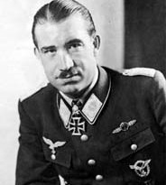
(Adolf "Dolfo" Joseph Ferdinand Galland was a German Luftwaffe general and flying ace who served throughout the Second World War in Europe.)
Thus, December 24th was on us and it was probably the saddest Christmas Eve of my life. We were in a family circle, but there was just no Christmas tree. The women tried to create a festive dinner. Kata baked the two hens which she had stuffed into the car in Székesfehérvár. However, when we tasted it, we had to stop in disgust the chickens were full of gasoline and the meat was inedible.
As the military police chief of our troops, my life was not easy, because discipline was becoming weaker. One morning our commander gave permission to the women to take the bus to the nearby small town, because they hoped that they could buy something there. Then I realized that the bus driver soldiers used this way to trade in the black market and found that the bus was full of food to be used as a basic means of barter. I ordered that the food be removed from the vehicle. A corporal refused to obey orders. I took out my gun and threatened to have to use my gun if he did not obey. He was still hesitant and I felt that I had come to the last moment and could not tolerate the hesitation any longer. I pulled the revolver lock and was ready to fire when the soldier, whose wife tried to pacify him, gave in and removed the black-market goods. I was later criticized at an officers meeting, that I had not used my gun, but the commander agreed with me and said I had acted moderately. Later, both the soldier and his wife thanked me for my restraint.
Imre Nemeth could see that we were in extreme conditions and did not object, but suggested that those who could, should arrange for their own food. The supply officer also tried to store as much food as possible, as before us was Germany, where there were very limited food conditions. Thus, not only the battalion’s supply office, but some of the family members bought pigs from farmers and many houses killed these pigs. Farmers were glad to get rid of their excess livestock, as it had been many weeks since regular transport to Pozsony ceased and anyway the feeling was that the soldiers could process what they wanted, because now it was certain that, sooner or later, everything will fall into the hands of the Russians. Farmers had no illusions about what the future would bring.
The make shift abattoir, with the fires burning the pigs, created an almost peaceful atmosphere, while everyone worked diligently to create an adequate food reserve to take with us to Germany.
Then the time came and we received our marching orders. I was at the front of the main branch of the battalion and left with six soldiers, I was selected as the commander of the group responsible for finding accommodation.
From this point the battalion relied on me for my German knowledge and I became virtually the battalion adjutant.
We set off in a small lorry and, in nearby villages, other forces vehicles’ joined our division’s ‘Accommodation Seeking Department’. Of course, this section had a higher commander, who arranged the necessary formalities for the border and in the snow wrapped country side, we barely noticed that we had crossed the border ... Later, I often thought back to these minutes, after all we had just lived through – our Hungarian history, which was repeated over and over when exiled boots traced marks in the snow of winter ... In our century, it was the automobile rubber wheels that left traces in the snow, but our crossing the border was painful because, by then, we had very little hope.
The last major German counter-attacks were stalled after the initial success and at this time the thought that kept our spirits alive was that at the moment of German defeat, the Western powers would not allow the victory of the Soviet Union over Europe to take place.
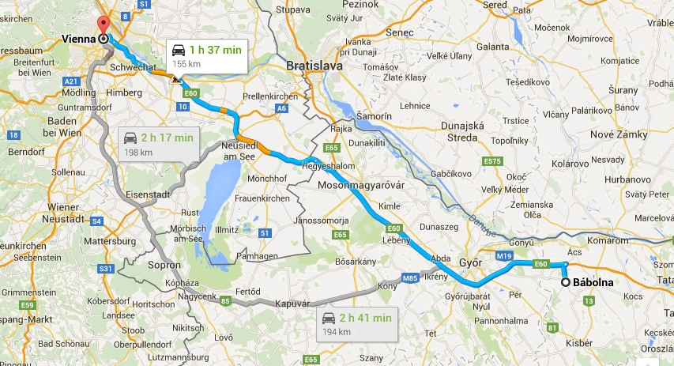
The truck raced towards Vienna and maybe we were the first Hungarian units in this sad retreat that reached the pleasant old imperial city. Now, however, it was bombed to destruction and the roads were almost impassible when we finally reached our designated goals in Vienna.
The troops were placed in the German Defense Force Migrating Quarters while the officers were directed to accommodation in an Officer Migrating Area. Great was my surprise when I realized that we were placed in the Habsburg Imperial Palace and it seemed almost incredible that we got one big room for ourselves.
Bábolna to Vienna

Maybe years ago, I went to these rooms possibly at a former diplomatic reception or a dance night when couples danced the waltz. Now there was 50-60 beds placed in the room one for each of us. There was a washroom facility as well. There was no question of heating and the cruel cold weather blew through the partially broken windows, we could only think of stripping off our boots stretching out on our beds with a couple of blankets.
Perhaps we slept for a couple hours, but rather we shivered through the night and we welcomed the morning. Within a few hours all was fine, we were together and we were ready with the troops for starting for our next three-to-four-hour journey. By this time, we knew that the Czech village close to the border, called Langau bei Geras, would be our quarters. The crew were better off than what we the officers were, because they were very satisfied with their bedding and were served a hot nutritious breakfast. In Vienna, the giant German protecting supply organization was still working.
In the afternoon our vehicles arrived in the assigned village and I made contact with the mayor. The mayor was a 50-year citizen of Langau, who received us very politely and it appeared to us that the village inhabitants understood of our situation.
Using the list I had, I managed to implement the task of finding accommodation. This meant the mayor had to commandeer rooms for us.
Then Sunday came and I took my little detachment to take part in the local population’s small church for Holy Mass.
I talked to the parish priest and as I learned later, the fact that my soldiers officially took part in the Holy Mass was received well and it created a very good impression with the local community and helped promote a good co-operation with the village, its leadership and us.
We even set up a dining area in one of the large halls in the local school.
When the battalion arrived with the family members, it really seemed that we had been fortunate in our transition in leaving our country. Imre Németh expressed his thanks and appreciation that, in general, the placement of the battalion and family members took place almost without errors. There were a couple of complaints, but we managed to solve them satisfactorily. The Török and Csabai families had been located in the large home of a family named Ries. Each room had five or six people but, in those times, this was a premier solution and the house had a large kitchen and a host of other options, so the women could be able to solve the problems related to small children.
We were relatively well equipped, but the situation on the war front left us in a downcast atmosphere. In early February, we launched a new battlefield supply’s route. Our supplies were running out and I gave one of my officers a pair of my Bilgeri boots and fur lined vest, previously reserved for me by the supply office. This fellow left with a heavy heart. We reserve officers could talk more openly in front of the crew and we made no secret that the war was over and Hungary only had a small area and there was no hope to turning around our destiny. Most of the soldiers were from Budapest and so were filled with concern as to what had happened to their loved ones in the besieged city. They headed to the front with the object of surrendering. Some of the troops accepted the view that responsibility would fall on the officers. But we officers saw more clearly the situation and we rather looked for ways of getting out of this situation. Nobody wanted to surrender to the Bolshevik forces.
Our command received an invitation that it was possible to volunteer individually in the Hunyadi armored SS Grenadier Division which was then under development. Both my brother-in-law Béla and I thought on the one hand we would gain time and on the other hand, if they deployed us into battle we would be volunteers, combat-ready and equipped ready to face the fortunes of war.
That is what we did, but neither the deployment of new troops nor the actual transfer of the armored Grenadier Division took place. Budapest also fell and the security of the Czech Republic was also threatened by the Russians and we had to consider continuing our withdrawal.
This is how we lived on March 15, our national day. The commander asked me to give an oration to the troops, highlighting the significance of this day. I could not imagine a more difficult speech for March 15. What could I say? It was already clear to us that we had failed and the future was dark. I talked about 1848 it and how Budapest had fallen, but later then things turned around and the country was liberated. I believed in this and in only a long exile. We waited in vain at each March 15 and even in October 1956 for this to happen.
It turned out I could return to Hungarian territory for a day or two again. At the headquarters, a much-decorated sergeant presented his case to resolve some status issue. I do not remember the details, as such cases were common then. His superiors knew that I was a judge at the Ministry of Justice and so they asked my opinion. I've found that in normal circumstances, the family law department could solve these problems. It raised the possibility of sending me to Szombathely, where the Department of Justice was still working on their evacuation, to try to solve the case.
This is how I was able to be in Szombathely in the last week of March at the Justice Ministry, which was located in one of the court buildings. There I met old colleagues who continued to serve. Many people did not volunteer to leave Budapest, but then staff numbers were still almost at full strength and it was nice to welcome old friends. In the case of the non-commissioned officer, I argued with the appropriate documents to one of the adjudicators and he promised to give a positive decision.
One colleague drew the Minister’s attention to the fact that, as a soldier, I was there on a visit from Germany and so the Minister called me to himself because he wanted to get first hand-formation on the German state of affairs. I talked to him honestly. I said that, unfortunately, there had been no new weapons, but, on the other hand, pointed out that even if the public was not enthusiastic and there was not much hope, there was discipline and order in the empire.
He knew that I had studied the functioning of German unions and he asked a lot of questions on this subject. Finally, while saying goodbye he expressed the hope that I would return as soon as possible to the Ministry of Justice. I politely took note of this, but the overall situation was such that I only had one thought and that was to return to my family and my duty station.
Early next morning I got on a train to Vienna. I wanted to visit the Hungarian Embassy. I knew that at the time Francis Vajta was in Vienna. We had previously met during my service in the ministry. He often visited István Antal since his days as the propaganda minister.
The train, however, often stood for hours in the open fields, and there were air raids and I arrived in Vienna in the evening. I was staying near the Capuchin crypt at an officer's temporary accommodation place. The population was now shaking because of the air attacks. Vienna had an air assault the previous night and the hotel landlady felt terrible in anticipation of a recurrence. I jokingly reassured her not worry, as I am now one of her guests and I always managed to avoid air raids. Indeed, I could sleep quietly throughout the night.
In the morning, I went to the consulate. Francis Vajta was not there. According to the secretariat, he had to travel to Hungary the previous day but was expected back sometime this morning. He arrived back at 10AM. Sadly, he greeted us and said only: “Hungary has fallen and now almost every inch of private land is in the hand of the Russians...”
He led me into his office and he described our hopeless situation. He said he did not know what he should do next...
I was very shocked by the news. He reported that a massive aerial attack hit Szombathely, just one day after my departure. He was almost amongst the victims.
Great changes were also taking place at Langau. Imre Németh, a few days earlier, had been ordered to the front where he took over the command of a battalion of the Szent László Division. He could only have taken part in last of the operations and we did not know his fate. Colonel Endre Zongor took over command and Captain Tihanyi became his advisor to organize further retreat.
Use of vehicles and fuel was curtailed, so family members had to face the fact that only forty kilograms of luggage were allocated per person. There were one or two families, who brought their own cars and they had their situation easier. Béla, my brother-in-law, was better off, because Béla had an Opel Olympia car. Kata packed the little car with the women and children to the point that Béla was afraid that the axel may break and insisted that a portion of the packages be removed.
My problem was that it was again my job to find accommodation for the battalion and I had to leave a day or two before my family and the appointed day of departure. During these last stages of the retreat, cars could not be allocated and the task was to use civilian railway transport in Bavaria to our destination in Eggenfelden, a little town where I had to report to Chief of Staff, Colonel Francis Koszorús, to receive further instructions. He was the commander of the armored division responsible for relocation of the remaining troops and he was in liaison with the respective department of the German Defense Force.
In peacetime conditions, the trip would have taken no more than a day, but now the railway connection faltered and the train stopped almost every two to three hours and many times we had to change trains. In such cases, sometimes we had to walk kilometers until we located the train where the line was not bombarded.
I went with Mária, our domestic servant, because the battalion did have an extra vehicle and Béla’s car was crowded with four children, two pregnant women (my wife and sister) and my old father, who was not much help. Mária was a lame girl with a dislocated hip and so I had to carry her bag often for many kilometers.
But somehow, we struggled on to Eggenfelden. This was now Bavaria where relatively peaceful conditions prevailed. At one of the Gasthof (German-style inn), I found Colonel Koszorús and I reported to him. We received accommodation at the same place. The Colonel’s aide was Lieutenant Egon Nezsényi who was an old friend from Bábolna and who had begun his military career back in 1937. When I was at the ‘Train Barracks’, he was one of my subordinates.
Vienna to Langau to Eggenfelden to Marklkofen
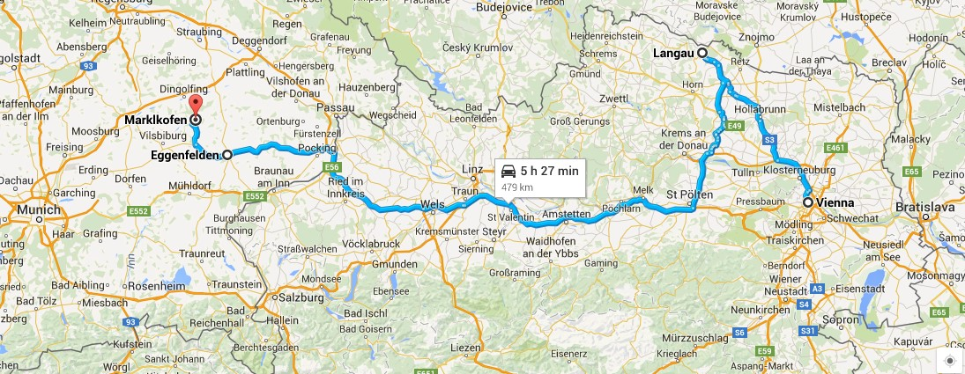
By this time, I saw clearly that the war was lost and I had no illusions, but it still hit hard when Colonel Koszorús outlined his own situation, in his cold measured chief of staff manner, that we had come to the last days.
The village of Marklkofen in Niederbayern (lower Bavaria) had been designated as the area for settlement of the battalion and Colonel Koszorús handed over the Wehrmacht High Command to the local authorities to assist us to carry out our duties.
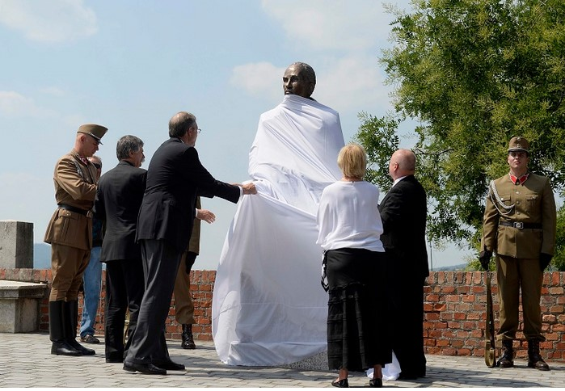
Then I met Lieutenant Ervin Hollósy, who was a commander of mine. He had been injured at the Battle of Arad and had joined my group when we had started for Marklkofen, which eventually became the last stop of the retreating battalion.
(The statue is a graceful testimony to the man who, upon the orders of Admiral Horthy, ordered his First Armored Division into action against László Baky and the collaborating pro-Nazi forces on July 5, 1944; temporarily preventing an Arrow Cross coup and halting the deportation of hundreds of thousands of Jews from Budapest. This unparalleled action was the only case known, in which an Axis power used military force for the purpose of preventing deportations. The action delayed the Nazi takeover for three and a half months, allowing tens of thousands to escape or find refuge and also permitted Raoul Wallenberg to coordinate his successful and effective rescue mission.)

